Instruction for CoFlame
Date: 2017/3/12
Version 1.3
Instruction is written by Yu Cheng and Nick Eaves. Any questions, please contact with Nick Eaves (nae28@cam.ac.uk) or Murray Thomson (murray.thomson@utoronto.ca) at University of Toronto, feedbacks and questions are appreciated.

- Function
CoFlame code is a parallel code written in FORTRAN which is used to model flame and soot formation for laminar coflow diffusion flames. This code was developed by many researchers in National Research Consul of Canada, University of British Colombia, Ryerson University and the University of Toronto and has been constantly improved and modified in the Combustion Research Laboratory over the last 10 years.

- Access
The paper on CoFlame 1.0 was published in July 2016 and may be downloaded from http://combustion.mie.utoronto.ca/?page_id=1005. If you are interested in using the code, please fill out the academic-user-form-for-coflame-code and send it to murray.thomson@utoronto.ca. We will send you the code ASAP. For industrial applications, please contact Prof. Thomson.

- References
To use this code, the users need to refer the following website and pulbication:
1. http://combustion.mie.utoronto.ca/?page_id=1005
2. Eaves, Nick A., et al. "CoFlame: A refined and validated numerical algorithm for modeling sooting laminar coflow diffusion flames." Computer Physics Communications 207 (2016): 464-477.

- Requirement of the machine
1. Compilation requires an intel compiler with openmpi.
2. Running CoFlame requires mpi capable machine with at least 4 processors, up to the number of control volumes in the axial direction.

E. Introduction
Step 1: Compiling CoFlame
- Compilation requires an intel compiler with openmpi
- Compile using the Makefile
Six files (cklib.o, derf.o, math.o, tranlib.o, CoFlame_v1_7.o and secondt.o) will be built in the compilation. If the compilation has been done and no changes have been made on the original files (cklib.f, derf.f, math.f, tranlib.f, CoFlame_v1_7.f and secondt.f), recompilation is not in need. Delete the .o files before compilation.
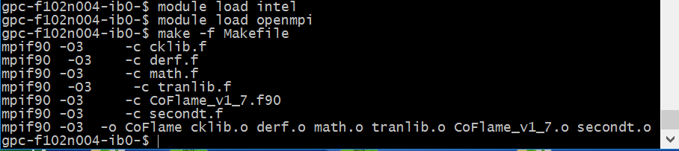

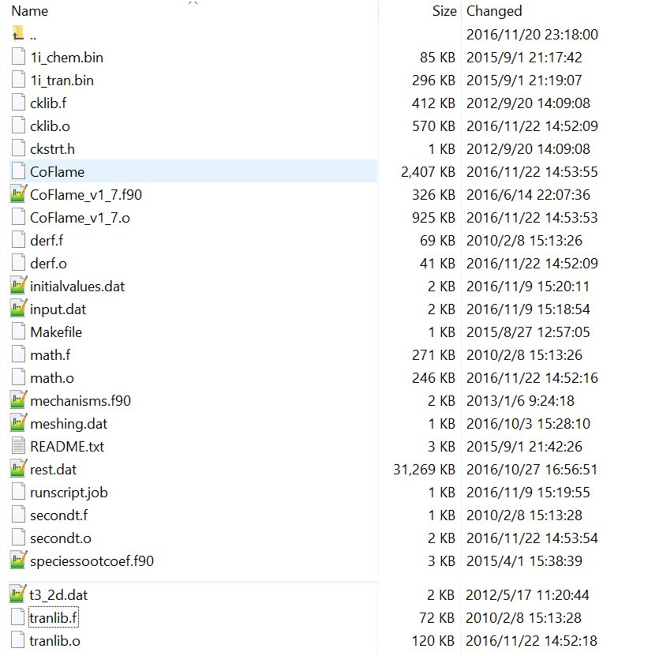

Step 2: Prepare the CoFlame Input Files

- Input.dat – including data regarding simulation run parameters, such as initial timestep, equations to solve, and details of which models to employ. Set proper value in your condition.
L3 is the number of CVs in the axial (x) direction per CPU, M3 is the number of CVs in the radical (y) direction. If the gird of 400x238 is used, the M3 is set to 238, you can either set L3 to 1, and run on 400 CPUs, or set L3 to 2, and run on 200 CPUs if you rather use less CPUs.
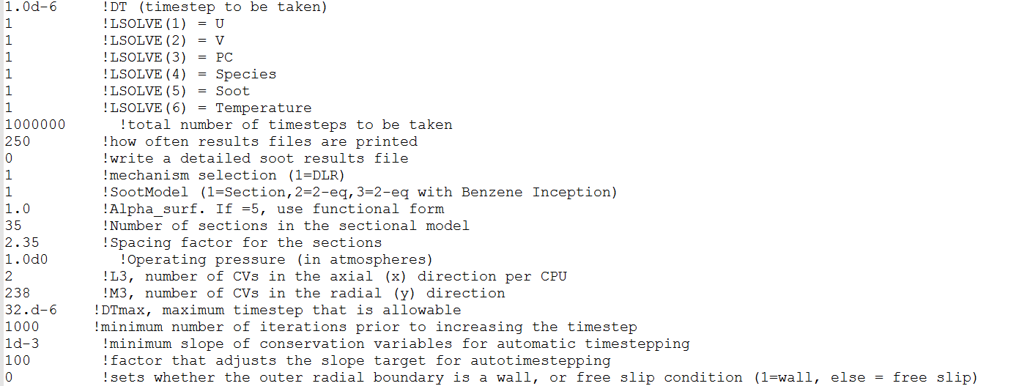

- Initialvalues.dat - including data for the initial solution to be used, and the inlet boundary conditions
If start a simulation from scratch, set the IREST flag 0; If continue from rest.dat, set the IREST flag 1.
Change the fuel tube data as specified, if the wall thickness of the fuel tube is not specified, 1mm (or 0.1cm) is a good assumption.
Set the inlet fuel and air data. The species index refers to the index in the mechanism.f90. The maximum number of the fuel species can be 6 and that of the air is 3. Please note that for any extra components that are not being utilized, please set the index to a species that is not part of the fuel or air stream. As example, if N2 is index 1 in the mechanism and O2 index 2, when specifying the species mole fractions for the oxidizer as air set the index of the third component (the unused component) to any valid index other than 1 and 2. If the third component is set to index 1 and mole fraction of 0, N2 will be set to have a mole fraction of 0, rather than the desired 0.791. The CoFlame code does not check if an inlet species mole fraction has been previously set and will simply over-right the specification if a subsequent component has the same index as a previous component.
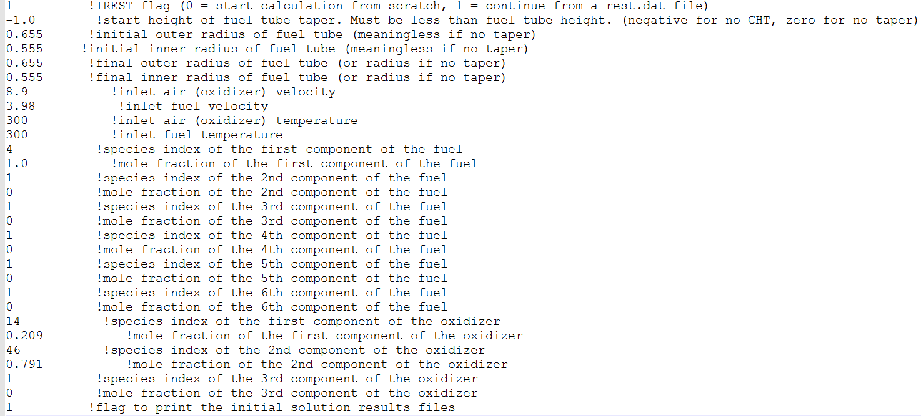
- Meshing.data - Contains data for constructing the 2D axisymmetric mesh
The code is set up to run a CHT simulation (means part of the fuel tube is included in the computational domain), which may not converge all that well without an initial guess. The strategy is to first run a case without CHT, then use the results of the non-CHT case to start the CHT case. To remove CHT from the simulation, you can adjust the parameter TUBEEND in meshing.dat to a negative number.
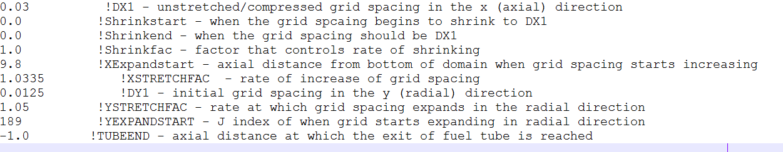
The code is sent with a setup for 400x238 CVs, includes CHT, and includes a refinement in the r-direction from r = 0.1 to 0.5, which is the same set-up as used to produce the results in the CPC manuscript. Please note that when trying to reproduce the results, a simulation without CHT and a coarser grid should be performed first and used as a starting point for the 400x238 CV CHT simulation. To remove the r-direction refinement, edit lines 737 to 741 of the CoFlame_v1_7_1.f90 code. To start a non-CHT solution, change the parameter TUBEEND in meshing.dat to a negative number, when it is set to -1, the grid of 368x238 is used.

- 1i_chem.bin - Chemical mechanism binary file in Chemkin format
- 1i_tran.bin - Transport binary file in Chemkin format
- Mechanisms.f90 - Contains data about the chemical mechanism, such as indicies of key species and header files for file output. Altering this file requires recompiling the code.
- Rest.dat - Input file for restarting a simulation from the results of a previous simulation. Not applicable if starting a simulation from scratch
If start a simulation from the results of a previous simulation, copy the last "SOLN" file to the rest.dat. Everytime starts from the results of a previous simulation, remember to look through the results file for '' Changing DT to '' check the final timestep. Change the timestep in the Input.dat file with the final timestep.

Step 3: Run the code.

You can get the following results files after running the code and all results files are appended with the iteration number they are associated with.
- "SOLN" files are used for restarting the code from a previous simulation. Copy them into rest.dat and change the correct flag in the initialvalues file to restart a simulation from that solution
- "SPEC" files contain results for flow and species variables. Written in tecplot format
- "soot" files contain results for average soot parameters. Written in tecplot format
- "sootdetail" contains results for each soot section. Only written if flag is set in the input.dat file. Written in tecplot format.
Full names and units of the abbreviations in the “soot” file are shown in Table 1.
Table 1. List of full names and units in the “soot” file.
Abbreviation | Full name | Unit
vol_frac | Soot volume fraction | ppm
Tot_Mass | Total mass | mg
Num_agg | Aggregate number density | #/cm3
Df_av_mass | Mass-averaged fractal diameter | nm
Df_av_num | Number-averaged fractal diameter | nm
Dv_av_mass | Mass-averaged volume-equivalent diameter | nm
Dv_av_num | Number-averaged volume-equivalent diameter | nm
Num_prime | Primary particle number density | #/cm³
Dp_av | Average primary particle diameter | nm
Usoot | Soot axial diffusional velocity | cm/s
Vsoot | Soot radial diffusional velocity | cm/s
IncepRate | Inception rate | g/cm³s
HACARate | HACA surface growth rate | g/cm³s
CondRate | Condensation rate | g/cm³s
O2_OxRate | O2 Oxidation rate | g/cm³s
OH_OxRate | OH Oxidation rate | g/cm³s

If the code diverged, there might be several plans:
- The code does automatically increase the time step, so it may diverge if the timestep increases it too much. Several parameters in the input.dat are related to the timestep, including the DT, DTmax and minimum number of iterations prior to increasing the timestep. One solution is to restart from previous simulation and fix the timestep to the one that prior to the timestep used in the divergence. You can also reduce the initial timestep in the input.dat file (DT) to 1d-7 or even 1d-8. Meanwhile, increase the minimum number of iterations prior to increasing the timestep and reduce the maximum allowable timestep (DTmax) in the input.dat file. As the solution becomes more converged, the maximum timestep can be increased.
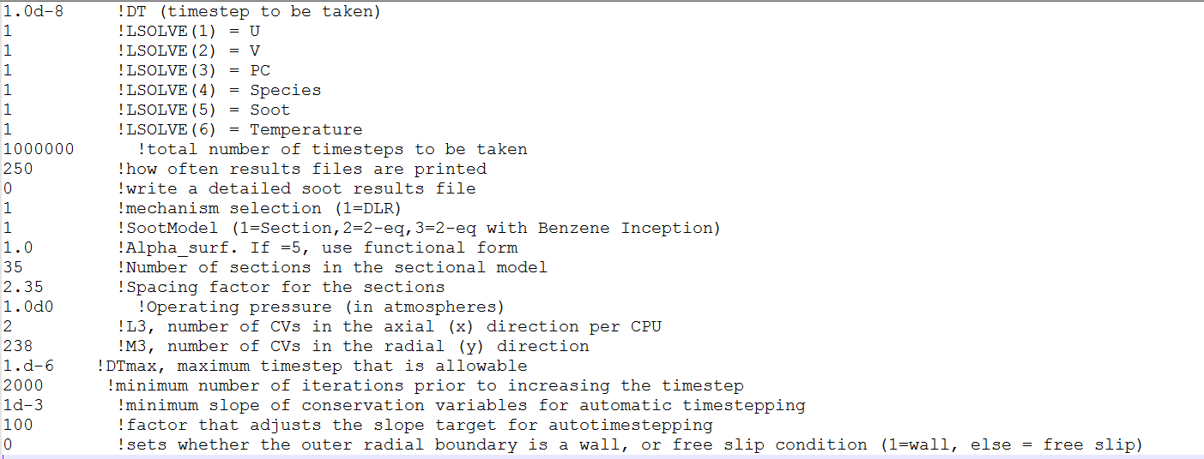
- The code may not converge all that well without an initial guess in a CHT simulation (means part of the fuel tube is included in the computational domain). In this case just adjust the parameter TUBEEND in meshing.dat to a negative number and run a case without CHT, then use the results of the non-CHT case to start the CHT case.
- You may restart from the previous “SOLN” files before the divergence.
- The code may diverge if the grid is too fine. So please try coarser grid when it still diverge.

